|  |
| --- |
| AKV Game Studios |
| Space Salvation |
| **“Rise or Fall, the Fate of Humanity Rests with You!”** |
| Version #3  All work Copyright © 2019 by AKV Game Studios.  All rights reserved. |
| **Andrei Laptev**  **Keshok Sivalingam**  **Victor Dallarosa Teixiera** |
|  |

|  |
| --- |
| March 31, 2019 |

# Table of Contents

Table of Contents 2

Version History 3

i. Game Overview 4

ii. Game Play Mechanics 4

*iii.* Camera 4

iv. Controls 4

v. Interface Sketch 5

vi. Menu and Screen Descriptions 9

vii. Game World 13

viii. Levels 13

ix. Game Progression 14

x. Characters 14

xi. Enemies 15

xii. Weapons 15

xiii. Items 15

xiv. Abilities 16

xv. Vehicles 16

xvi. Script 16

xvii. Scoring 16

xviii. Sound Index 17

xix. Story Index 17

xx. Art / Multimedia Index 18

xxi. Future Features 18

# Version History

[This is where you keep track of the detailed changes made to your document throughout the course of development.]

# Game Overview

The main goal of the game is to create a top-down 2D shooter that will bring back some old, nostalgic memories from the illustrious period of gaming. Our game is simple and user-friendly to play. The objective is to defeat enemy ships. They pose a big threat to you and the rest of humanity. Their leader has waged war on your species, and he’s battle tested. You must rise and fight. Take down the leader and bring glory to your people. Save your people from annihilation.

# Game Play Mechanics

The player has the following abilities:

* Collect coins that spawn from above; collecting each coin will grant you 100 points
* Collect health packs that spawn from above, granting the Player health points in increments of 10 when obtained
* Fire at enemy ship(s)
* Destroy the enemy ship to proceed; essential to proceed to the next level.
* Collect powerups (nuclear bullet); inflicts more damage than standard bullet

# Camera

The game is a 2D based, top-down shooter. Camera angle is aerial view.

# Controls

The game heavily relies on mouse controls. Moving the mouse cursor will allow the Player to navigate the ship it the direction of its situated position. To elaborate, as the cursor moves around the screen, the ship you command will gravitate towards its pointed location. On one hand, left clicking on the mouse will fire bullets; on the other hand, right clicking on the mouse will activate a powerup ability (nuclear bullet). The latter is not available until level 3. Alternatively, you can perform the same following pair of commands by hitting the spacebar key and left shift key respectively.

**Keyboard Map**

* Shoot: Spacebar
* Shoot (Nuke): Left shift

**Mouse Map**

* Move: Cursor
* Shoot: Left click
* Shoot (Nuke): Right click

**Xbox 360/One Controller Map**

* Move: Left stick
* Shoot: A
* Shoot (Nuke): B

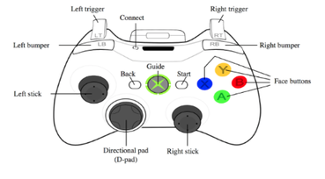

# Interface Sketch

**Level One**

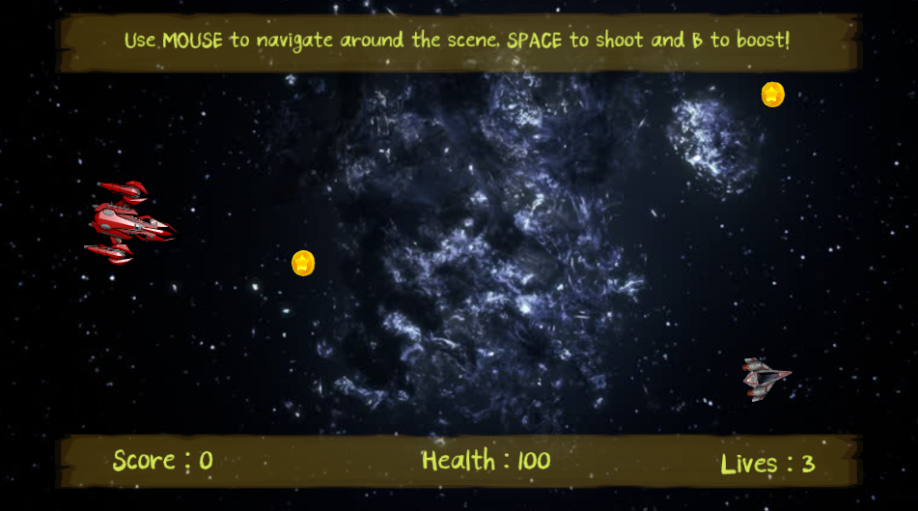

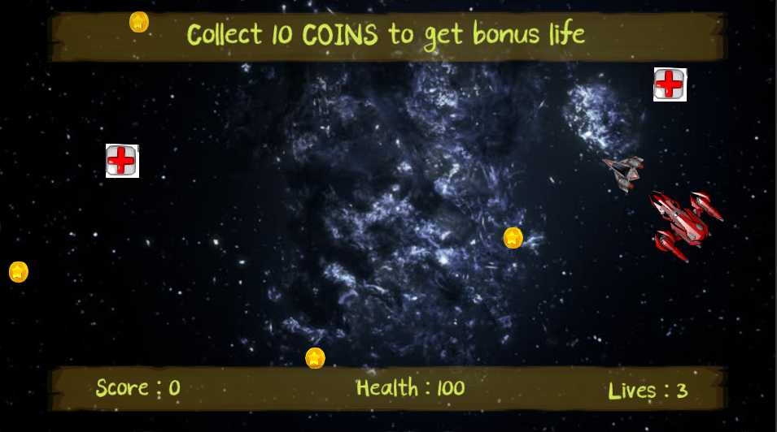

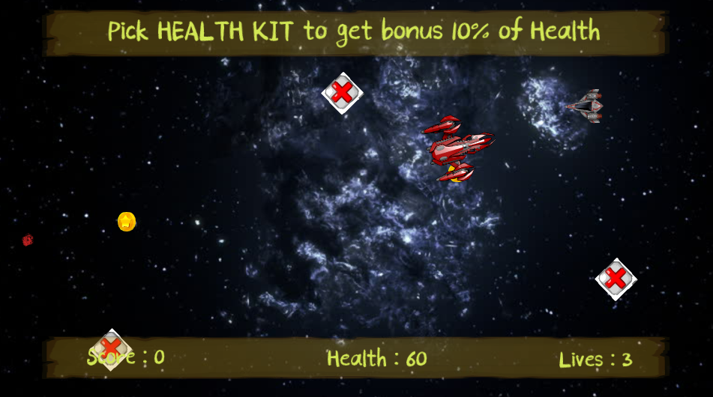

**Level Two**

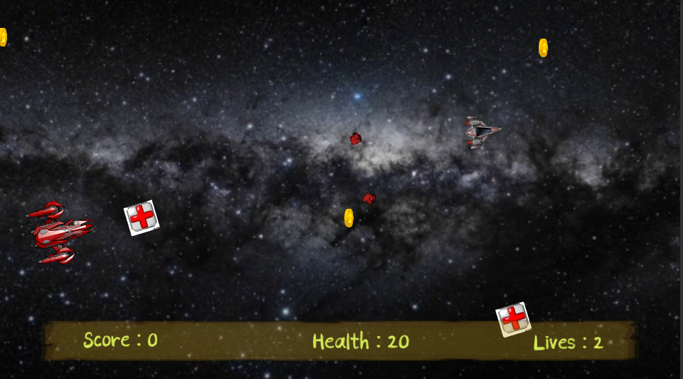

**Level Three**

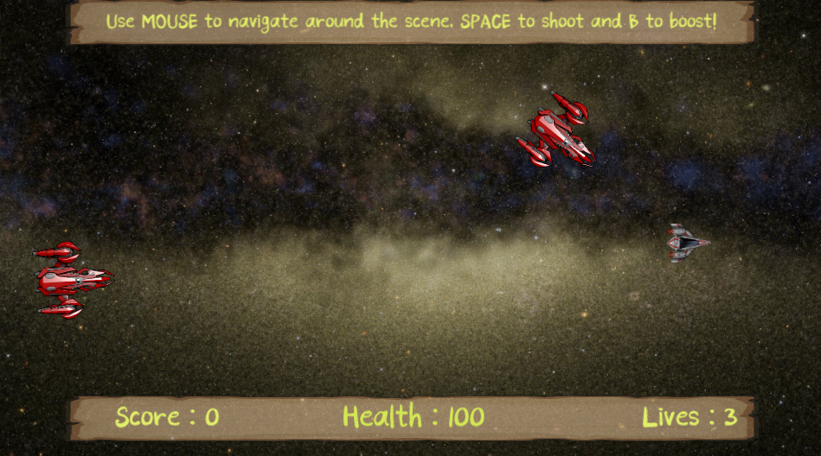

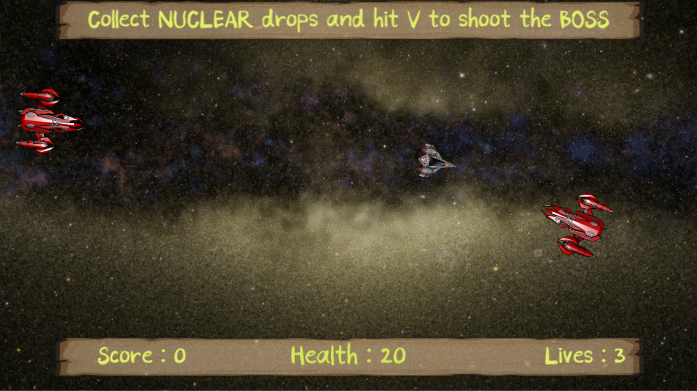

# Menu and Screen Descriptions

**Main Menu**

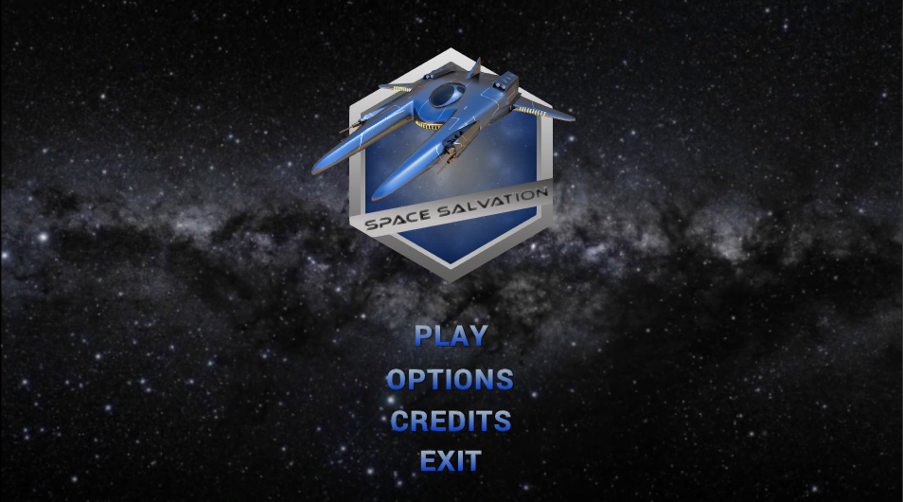

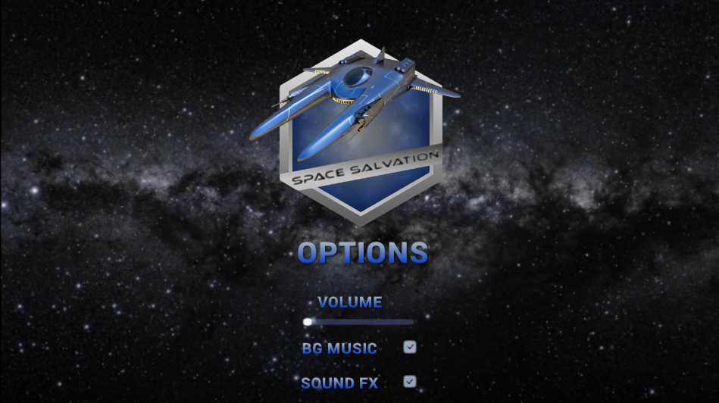

**Credits**

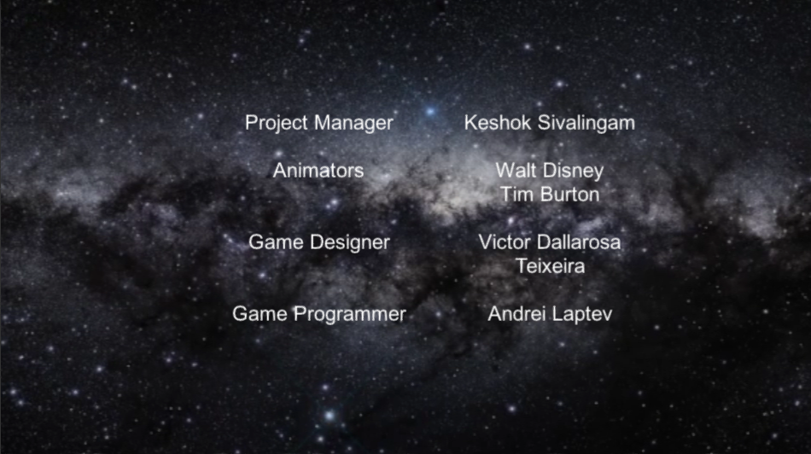

**Post Level Title Screens** (for each respective level)

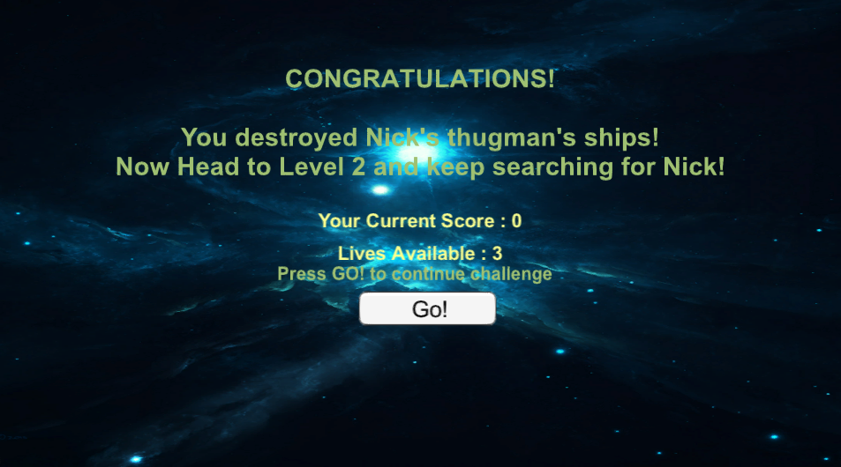

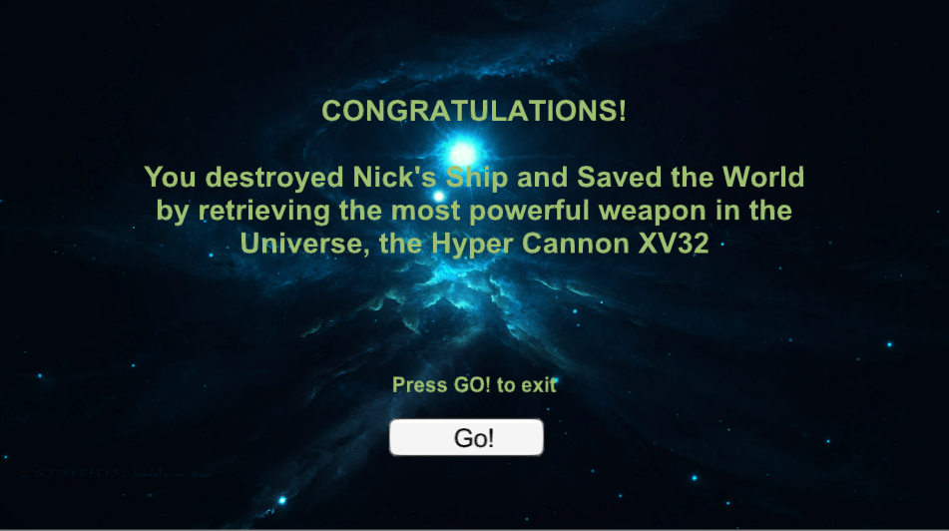

**Post Player Death Title Screens** (for each respective level)

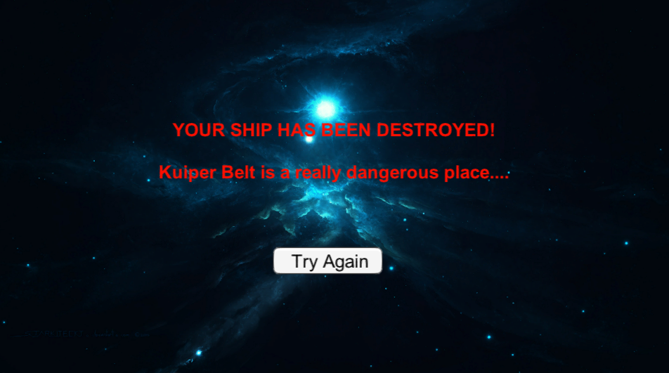

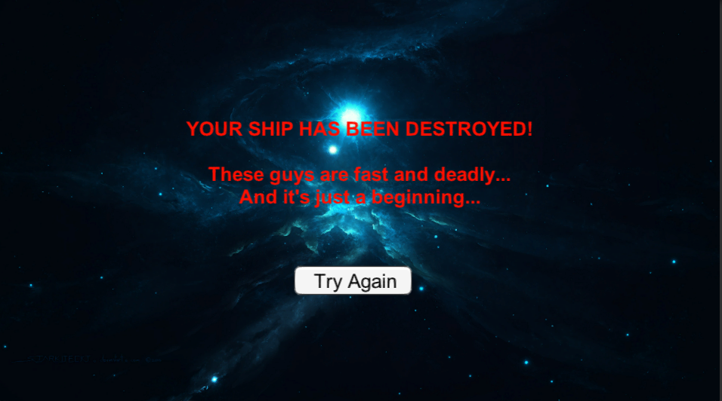

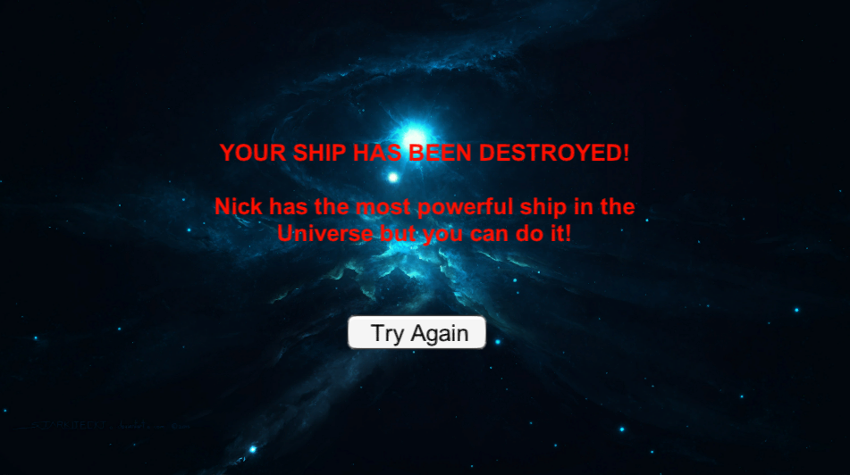

# Game World

The game world and setting are situated somewhere in deep space. It’s the year 2077, and the Earth is inhabitable due to a nuclear fallout from a never-ending war that lasted a whole decade. Humans had to abandon Mother Earth and settle in space, living on arcs and space shuttles. The fate of humanity has been in salvation ever since, but a new threat has emerged. Just when they thought they were in the clear, a new opposing force emerges. They are like no other. They’ve conquered many worlds, planets and galaxies. Nothing stands in their way of destruction. They must pick up arms, go to war, fend their attacks, and defeat their leader.

The game environment is strictly 2D. The game is an arcade style spaceship shooter, inspired by many top-down shooters that have come before. Heavy influence and adaptions were loosely made from pop culture films and television. It has driven and motivated us to pay homage as well as to carry on the torch to our younger generation. The game is developed using Unity game engine. The ambient lighting of our game isn’t dark nor shallow. We opted for a brighter atmospheric game lightening, so that the game is well balanced and an easy plug and play.

# Levels

**In the introductory level:**

* Player can collect coins to score points; the higher, the merrier
* Player can collect health packs to increase their health
* Player can aim, target and fire at enemy ship
* Each hit the Player endures, a portion of his health will be reduced
* Enemy ship shoots in burst of two bullets at the same time; whereas, Player ship fires a single bullet per trigger
* Player must defeat enemy ship to proceed to the next level
* Player has three lives

**In the second level**, it’s mostly the same as level one except for a few changes. These changes include:

* Enemy ship navigates around the screen more quickly and vividly
* Enemy ship fires more frequently with better aim and accuracy
* Another enemy ship spawns right after the Player takes down the first enemy

**In the final level**, there are substantial differences from levels one and two. These following changes are:

* Coins and health packs are removed
* Player must combat and challenge two enemy ships simultaneously
* When Player destroys one enemy ship, they can collect a powerup ability (nuclear bullet)
* Firing a nuclear bullet will inflict significant damage to the opponent
* Player encounters Boss when both enemy ships are destroyed
* Boss is distinctive; drops a wave of bombs
* In the array of bombs the Boss releases on Player, Player can navigate around or in between the cluster of bombs and collect a nuclear bullet.
* Player can aim, target and fire at Boss ship
* Defeat Boss to complete the entire game

# Game Progression

The game progresses as the Player defeats each level. Scores and remaining lives of the Player will carry over to the next level. Each level comes with its own fair of challenges. The higher the level, the higher the stakes and challenges the Player must overcome. At the end of the game, your score points are tallied and summed up. The Player has the option and freewill to re-play the game and attempt a higher score than their previous record.

# Characters

The main character of the game is the spaceship the Player pilots. The ship is their identity and trademark. It has gone through a lot of beatings, ricochets, collisions, maintenance and repair, yet it is still operational and in working order. A new looming threat has surfaced, and the fate of humanity is on the fringe. It must once again join the battlefront and go behind enemy line to salvage and save mankind.

# Enemies

Enemies are present in each level of the game. Difficulty of the AI is strengthened as the Player progresses each level. The AI takes control of enemy spaceships. They are advanced, bigger in size compared to the ship the Player controls. These ships fire two bullets simultaneously. Player will encounter Boss in the final level of the game, right after they take down two enemy ships. In fact, the Boss takes flight in a spacecraft that is other-worldly. It’s deadly, lethal and multitude in size. It can withstand a lot more damage; thus, taking it down will require a lot of fire power and intelligence to avoid its bombs that drop from the craft.

# Weapons

There are only two weapons available in the game. They are a generic bullet and a nuclear bullet. For the most part of the game, the Player must get through each level with a single blasting bullet that’s triggered when fired. Once the Player reaches the third level, they can collect a limited powerup that will upgrade their bullet to a nuclear variant. It’s more devasting when fired upon, as it will inflict severe damage to the opposing force.

# Items

There are three collectable items in the game. They include the following: coins, health packs, and nuclear bullet. When the Player collects coins, it raises their score. Higher the score, greater your bragging rights. Furthermore, health packs will aid and replenish some health to the Player, when they’ve taken damage, so that they can remain alive and stay in the fight. However, they only get three lives to complete the entire game. Finally, the Player can obtain a special powerup (only available in level 3) that will grant them the ability to wield a nuclear bullet. This bullet will do more significant damage oppose to the standard bullet. More importantly, they must use it wisely because they can only fire and wield it one at a time. After firing a singular nuclear bullet, the Player must collect another when they spawn and appear on screen.

# Abilities

There is only special ability in the game, and that is a nuclear bullet. The elusive powerup appears in level 3, and it can only be attained at this stage of the game. When the Player obtains this ability, they can fire this bullet at one of the enemy ships. If the special bullet hits the enemy ship, then it will do some substantial damage to it. This, in a way, can help the Player finish off their opponent with minimal effort and efficiency. To collect this powerup, the Player must destroy one of the enemy ships during level 3. If they are successful, then the enemy ship will drop a nuclear bullet. More importantly, this bullet can only be fired and summoned once until the Player acquires another.

# Vehicles

The vehicles that are utilized in this game are space-oriented aerial saucers, ships and flying objects. Since our game is situated in deep space, the Player will be taking flight on a spaceship. The enemies, controlled by AI, will also be transporting on spaceships. The Boss, however, will be flying on huge saucer-like spacecraft. It’s a one a kind, and it is enormous in size and weight.

# Script

# Scoring

Scoring in the game can be achieved by collecting coins that spawn at the top of the screen. It gradually drops down, makes its way to the center and ultimately dispersing when it reaches the bottom of the screen. The Player can navigate their ship and collect as much coins they possibly can before they vanish and stop appearing. To reiterate, It is important to point out that coins do stop spawning after a certain time interval; therefore, this makes it more challenging for the Player because they must look out for the enemy’s bullet meanwhile keeping an eye out for health packs to aid and regenerate Player health.

# Sound Index

1. **Effects**
   * Fire
     1. Standard (retro 8-bit laser sound)
     2. Nuke (big explosion sound)
   * Enemy Fire (shot cannon, dual laser sound)
   * Bombs (bombs away, bomb-whistle sound)
   * Explosions
2. **Feedback**
   * Player Death (sad chime)
   * Enemy Death (victory chime)
   * Damage/Hits
   * Coin Grab (retro 8-bit coin sound)
   * Health Pack (powerup or health regen sound)
   * Collect Nuclear Bullet (recharge or fueling canon sound)
3. **Music**
   * Medium to fast tempo, nerve-racking “boss” track
   * Space-themed, upbeat sci-fi track for levels 1 and 2
   * Techno, cyber-funk “space” track
   * A victorious post-level title screen track
   * A sad chiming death screen track
   * Riveting title and main menu track
   * Happy ending rolling credits track

# Story Index

1. **Main Menu**
2. **Level One**
3. **Level Two**
4. **Level Three**
5. **Credit**

# Art / Multimedia Index

1. **Animations**
2. **Blocks**
3. **Sprites**
4. **Ambient**
5. **Fonts**
6. **Background**

# Future Features

Features that we plan to implement in the future include the following:

* Joystick and gamepad support
* Eradicate and squash bugs
* Leader and scoreboard
* Saving and loading
* Adding more game levels